Rafting Site Plan

1. Logo

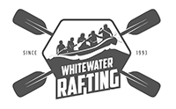

2. Color Scheme:

primary-color: #363537

secondary-color: #ef2d56

accent1-color: #ed7d3a

accent2-color: #8cd867

Color Palette URL: https://coolors.co/363537-ef2d56-ed7d3a-8cd867-2fbf71

3. Fonts:

heading-font: Georgia

text-font: Roboto